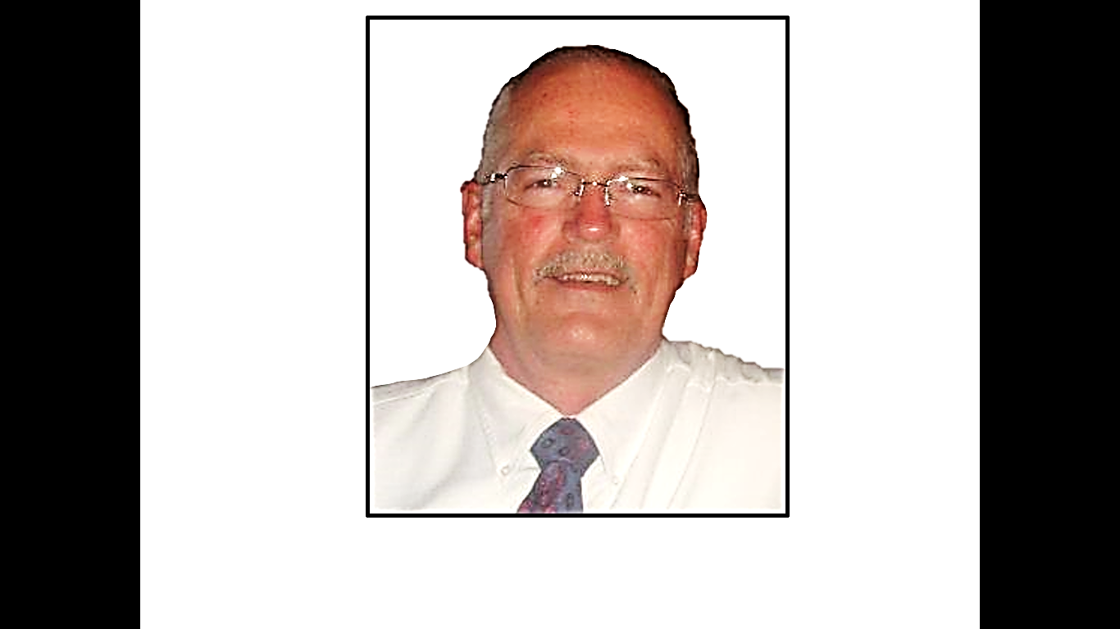







**Darren Crownover** is a coach and

school teacher

that is well known

and respected in the

community.

He teaches adult and

teen Bible classes.

**Mike Hollingsworth** is a manager

at Walmart. His

people skills are a

great asset to the

church.

He teaches adult

Bible classes.

**Gary McDade** is an elder and the

preacher. He also

has been a

financial planner

for over twenty

years. He has a

B.A. in Bible from

Freed Hardeman

University and a M.A.

from Amridge

University.

**LET US PRESENT**

**A Home Bible Study**

**In Your Living Room**

of the five lesson

Visualized

Bible Study Films

Phone: 423-800-2858

**OUR**

**ELDERS**

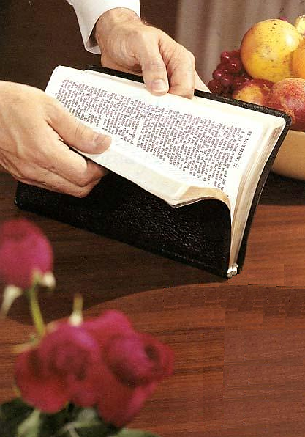

**The Gospel Plan**

**Of Salvation**

HEAR the Gospel

Romans 10:17

BELIEVE the Gospel

John 3:16

REPENT of Sins

Luke 13:3

CONFESS Christ

Romans 10:9-10

Be BAPTIZED

Acts 2:38

LIVE FAITHFULLY